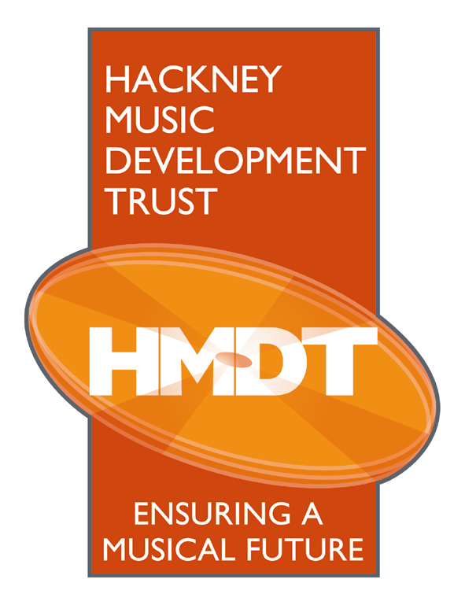
Technology Learning Centre
1 Reading Lane
London E8 1GQ

Tel 020 8820 7410

Fax 020 8820 7118
E-mail info@hmdt.org.uk

Registered Charity No. 1050520

ORDER FORM

Cherry Pie
A collection of traditional and multicultural children’s songs from around the world. The pack includes a CD and information on how to use the material for music training. It is fun and easy to use.

Each Cherry Pie pack costs £10.00

1,2,3 Sing and Move With Me!
A resource pack including a variety of songs from a range of cultures and with a particular focus on Turkish music and dance. Each song is presented from four different perspectives; Singing, Moving, Playing and Extending and is accompanied by a CD. Other sections include Preparing the Voice and Body, Using Percussion Instruments, a summary of QCA Early Years education objectives and a Resource List.

Each 1,2,3 Sing and Move With Me! pack costs £15.00

** SPECIAL OFFER **
Pay only £20.00 (including P&P) when you buy both Cherry Pie and
1,2,3 Sing and Move With Me! books.

Please make cheques payable to Hackney Music Development Trust

Please post the cheque with the completed slip below to:

Hackney Music Development Trust
The Technology Learning Centre
1 Reading Lane
London
E8 1GQ


PLEASE FILL IN AND RETURN THIS PART OF THE FORM WITH YOUR CHEQUE TO:
Hackney Music Development Trust
The Technology Learning Centre - 1 Reading Lane - London - E8 1GQ

Your name …………………………………………………………………………………
Your address …………………………………………………………………………………
…………………………………………………………………………………
Your postcode …… ……

The number of Cherry Pie packs you require …………
The number of 1,2,3 Sing and Move With Me! books you require ………….

Your cheque is made payable to Hackney Music Development Trust for the amount £………..

